The seashore is a great place to explore. Try using the Seashore Treasure Hunt and find lots of amazing shells, flotsam and jetsam, seaweeds, stones and more.
Seashore Treasure Hunt

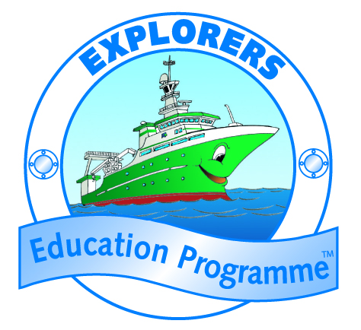
Work out the clues below to help you find seashore ‘treasure’ as well as marine debris. If you can’t get to the seashore, maybe try working out the answers and either draw or find pictures online of the seashore treasures.

- I look like a volcano and have a foot like a rasp. Find an empty one of me shouldn’t be too much of a task?
- Something yellow, red or black … I am very little and often can be found washed up on the sand.
- I'm green and slimy and limpets love me. But take care not to walk over me where you might slip and hurt your knee.
- I'm hollow and light and help birds take flight.
- Something that makes a noise. You might bang, tap or squeeze me. Humans can accidently or intentionally dump me at the sea.
- I’m mentioned in the song along with muscles in Alive-alive-o. Empty ones can often be found on the shore line.
- I've got air bladders to keep me afloat.
- I'm part of the earth, sometimes hard, ragged or round and difficult to walk across. I can be tiny, medium sized or very large - too heavy to lift.
- I have come from the sea where I was dumped by accident or intentionally. On the beach I don’t belong but often can be found. Put me in a recycling bin would make everyone happy.
- I might shine or not… I might be from nature or not… but to you I remind you of a little piece of treasure and you like me a lot.

SEASHORE TREASURE HUNT CLUES
CLUES and ANSWERS:

1. I look like a volcano and have a foot like a rasp. Find an empty one of me shouldn’t be too much of a task? Limpet shell
2. Something yellow, red or black … I am very little and often can be found washed up on the sand. Smooth or flat periwinkles
3. I'm green and slimy and limpets love me. But take care not to walk over me where you might slip and hurt your knee. Green seaweed
4. I'm hollow and light and help birds take flight. Feather
5. Something that makes a noise. You might bang, tap or squeeze me. Humans can accidently or intentionally dump me at the sea. Flotsam, Jetsam or Marine debris
6. I’m mentioned in the song along with muscles in Alive-alive-o. Empty ones can often be found on the shore line. Cockle shells
7. I've got air bladders to keep me afloat. Seaweed
8. I'm part of the earth, sometimes hard, ragged or round and difficult to walk across. I can be tiny, medium sized or very large - too heavy to lift. Stones or Rocks
9. I have come from the sea where I was dumped by accident or intentionally. On the beach I don’t belong but often can be found. Put me in a recycling bin would make everyone happy. Litter / Marine debris
10. I might shine or not… I might be from nature or not… but to you I remind you of a little piece of treasure and you like me a lot. Anything from the seashore that students like.

